**Portfolio 1**

Medium Risk Portfolio. Quarterly Report.

|  |  |
| --- | --- |
| Account Balance, CAD (as of June 1, 2019) | 505878.3 |
| Account Opening Date | April 1, 2014 |
| Initial Amount Invested | $200,000 |
| Cash Contribution, CAD (semi-annual) | $20,000 |
| Total Return since Inception (annualized) | 16.7% |

Graph of Portfolio growth

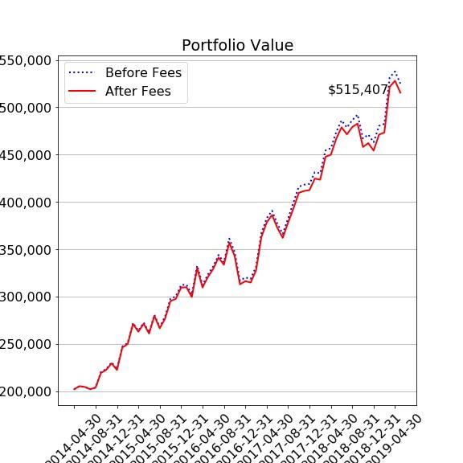

Investment Objectives

|  |  |
| --- | --- |
| Investment Tenure | 5 years |
| Target Wealth, CAD (without additional contributions) | $300,000 |
| Desired Probability of Reaching Target Wealth | 75% |
| Minimum Acceptable Wealth, CAD | $100,000 |
| Probability of Maintaining Minimum Wealth | 95% |

Portfolio Composition

Bar Chart of Weights

|  |  |
| --- | --- |
| Security Ticker | Number of Shares Held as of June 1, 2019 |
| MRD.TO | 3029.72 |
| CIM.AX | -352.14 |
| GAPSX | 23788.88 |
| LNC | -1926.66 |
| KNEBV.HE | 938.34 |

Pie Chart of Absolute Percentage Exposure to Asset Class

Pie Chart of Absolute Percentage Exposure to Country

Pie Chart of Absolute Percentage Exposure to Sector

|  |  |  |  |  |
| --- | --- | --- | --- | --- |
| Security Ticker | Instrument Type | Asset Class | Country | Sector |
| MRD.TO | Equity | Equity:CAD | Canada | Real Estate |
| CIM.AX | Equity | Equity:AUD | Australia | Industrials |
| GAPSX | Equity | Equity:USD | NaN | NaN |
| LNC | Equity | Equity:USD | United States | Financial Services |
| KNEBV.HE | Equity | Equity:EUR | Finland | Industrials |

Return Metrics

Graph of Portfolio Growth vs Benchmark

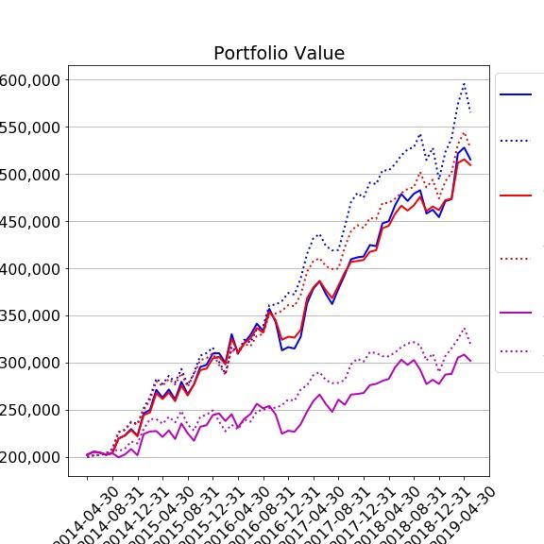

Account Balance

|  |  |
| --- | --- |
|  | CAD (as of June 1, 2019) |
| Portfolio | 505878.3 |
| Benchmark[1] | 554461.9 |
| Portfolio w/o Rebalancing | 501042.8 |
| Benchmark w/o Rebalancing | 518813.3 |
| Portfolio w/o Cash Contributions & Rebalancing | 294277.8 |
| Benchmark w/o Cash Contributions & Rebalancing | 311624.1 |

Simple Return, % annualized

|  |  |  |  |
| --- | --- | --- | --- |
|  | Last Quarter | Last Year | Since Inception |
| Portfolio | 16.2% | 9.2% | 19.7% |
| Benchmark[2] | 3.3% | 9.2% | 21.8% |
| Portfolio w/o Rebalancing | 11.7% | 10.3% | 19.4% |
| Benchmark w/o Rebalancing | 3.4% | 10.1% | 20.2% |
| Portfolio w/o Cash Contributions & Rebalancing | 17.2% | 1.1% | 7.8% |
| Benchmark w/o Cash Contributions & Rebalancing | 3.4% | 1.3% | 9.0% |

Money-Weighted Return, % annualized

|  |  |  |  |
| --- | --- | --- | --- |
|  | Last Quarter | Last Year | Since Inception |
| Portfolio | 37.3% | 18.6% | 36.0% |
| Benchmark[3] | 19.7% | 17.7% | 37.8% |
| Portfolio w/o Rebalancing | 31.9% | 20.0% | 35.8% |
| Benchmark w/o Rebalancing | 21.0% | 19.4% | 36.5% |
| Portfolio w/o Cash Contributions & Rebalancing | 56.8% | 15.9% | 26.6% |
| Benchmark w/o Cash Contributions & Rebalancing | 34.8% | 15.3% | 27.5% |

Time-Weighted Return, % annualized

|  |  |  |  |
| --- | --- | --- | --- |
|  | Last Quarter | Last Year | Since Inception |
| Portfolio | -0.9% | 0.8% | 7.1% |
| Benchmark[4] | -10.3% | 1.5% | 9.6% |
| Portfolio w/o Rebalancing | -4.8% | 1.7% | 6.8% |
| Benchmark w/o Rebalancing | -11.1% | 1.9% | 7.9% |
| Portfolio w/o Cash Contributions & Rebalancing | -10.6% | -11.6% | -7.5% |
| Benchmark w/o Cash Contributions & Rebalancing | -19.4% | -10.6% | -5.8% |

Comments about TWR vs MWR, Vol & Ret of benchmark vs Portfolio

Return Attribution by Security

|  |  |
| --- | --- |
| Security | Return Contributed over Last Quarter,  % annualized |
|  |  |
|  |  |
|  |  |

Return Attribution by Currency

|  |  |
| --- | --- |
| Currency | Return Contributed over Last Quarter,  % annualized |
| AUD | 0.003% |
| CAD | 0% |
| EUR | 0.75% |
| USD | 2.2% |

Risk Metrics

Volatility, % annualized

|  |  |  |  |
| --- | --- | --- | --- |
|  | Last Quarter | Last Year | Since Inception |
| Portfolio | 6.3% | 12.4% | 14.2% |
| Benchmark[5] | 15.6% | 15.0% | 12.3% |
| Portfolio w/o Rebalancing | 3.4% | 9.2% | 11.8% |
| Benchmark w/o Rebalancing | 9.9% | 10.6% | 10.4% |
| Portfolio w/o Cash Contributions & Rebalancing | 5.5% | 10.8% | 12.4% |
| Benchmark w/o Cash Contributions & Rebalancing | 15.6% | 13.8% | 10.6% |

Sharpe Ratio

|  |  |  |  |
| --- | --- | --- | --- |
|  | Last Quarter | Last Year | Since Inception |
| Portfolio | 2.22 | 0.57 | 1.35 |
| Benchmark[6] | 0.07 | 0.47 | 1.71 |
| Portfolio w/o Rebalancing | 2.74 | 0.90 | 1.59 |
| Benchmark w/o Rebalancing | 0.11 | 0.76 | 1.87 |
| Portfolio w/o Cash Contributions & Rebalancing | 2.70 | -0.09 | 0.57 |
| Benchmark w/o Cash Contributions & Rebalancing | 0.07 | -0.06 | 0.78 |

Max Drawdown

|  |  |  |  |
| --- | --- | --- | --- |
|  | Last Quarter | Last Year | Since Inception |
| Portfolio | -2.4% | -5.9% | -12.3% |
| Benchmark[7] | -5.1% | -9.0% | -9.0% |
| Portfolio w/o Rebalancing | -1.2% | -3.3% | -8.5% |
| Benchmark w/o Rebalancing | -3.2% | -5.7% | -7.3% |
| Portfolio w/o Cash Contributions & Rebalancing | -2.1% | -8.9% | -12.8% |
| Benchmark w/o Cash Contributions & Rebalancing | -5.1% | -10.4% | -10.4% |

VaR of Portfolio

Marginal VaRs

|  |  |  |  |  |  |
| --- | --- | --- | --- | --- | --- |
| Security | MRD.TO | CIM.AX | GAPSX | LNC | KNEBV.HE |
| MVaR | 1469.6 | -1106.2 | 114143.8 | -44361.3 | 5457.2 |

|  |  |
| --- | --- |
| **Risk Factors** | **MVaR** |
| **Mkt-RF_log** | 68723.1 |
| **SMB_log** | -26.9 |
| **HML_log** | 6931.3 |
| **RMW_log** | -825.8 |
| **CMA_log** | -3597.5 |
| **Mkt-RF_log_global** | 237.5 |
| **SMB_log_global** | -174.2 |
| **HML_log_global** | 276.7 |
| **RMW_log_global** | -30.5 |
| **CMA_log_global** | 229.9 |
| **CADUSD=X** | -49.8 |
| **AUDUSD=X** | -110.7 |
| **Mkt-RF_log_EUR** | 4571.1 |
| **SMB_log_EUR** | 351.7 |
| **HML_log_EUR** | 139.0 |
| **RMW_log_EUR** | -65.9 |
| **CMA_log_EUR** | 400.8 |
| **EURUSD=X** | 168.9 |

Comments and Recommendations

1. 100% investment in ACWI ETF considered as a benchmark
2. 100% investment in ACWI ETF considered as a benchmark
3. 100% investment in ACWI ETF considered as a benchmark
4. 100% investment in ACWI ETF considered as a benchmark
5. 100% investment in ACWI ETF considered as a benchmark
6. 100% investment in ACWI ETF considered as a benchmark
7. 100% investment in ACWI ETF considered as a benchmark